**UNIT-2**

**1. Methods of Production\Production Function?**

In simple words, production function refers to the functional relationship between the number of goods produced (output) and factors of production (inputs). Production involves the transformation of inputs such as capital, equipment, labor, and land into an output - goods and services. Production is the main activity for all businesses. The main object of production is to make finished goods and satisfy consumer needs. In this production process, the manager is concerned with efficiency in the use of the inputs. production management is the process of planning & regulating the operations of that part of a business that is responsible for the actual transformation of materials into finished products.

**Production Function**

A *production function* is a purely technical relation that connects factor inputs & outputs

Q = f( L,K,R,Ld,T,t)

where

Q = ou tput R= Raw Material

L= Labour Ld = Land

K= Capital T = Technology

t = time

**Types of production function:**

**1.Production function with one variable or Law of variable proportions:**

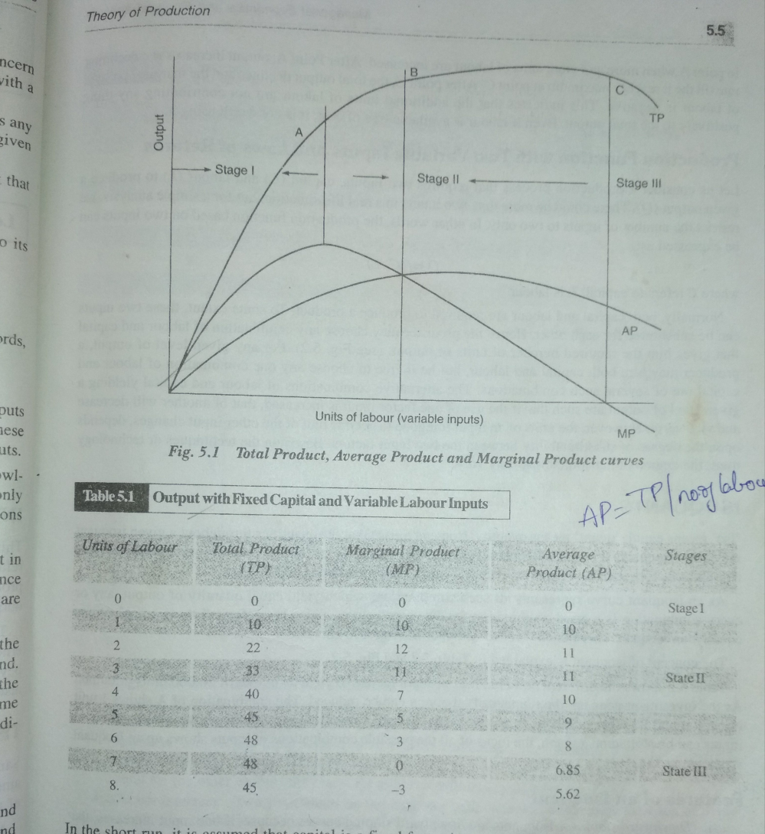

**2.Production function with Two variables or ISO quants**

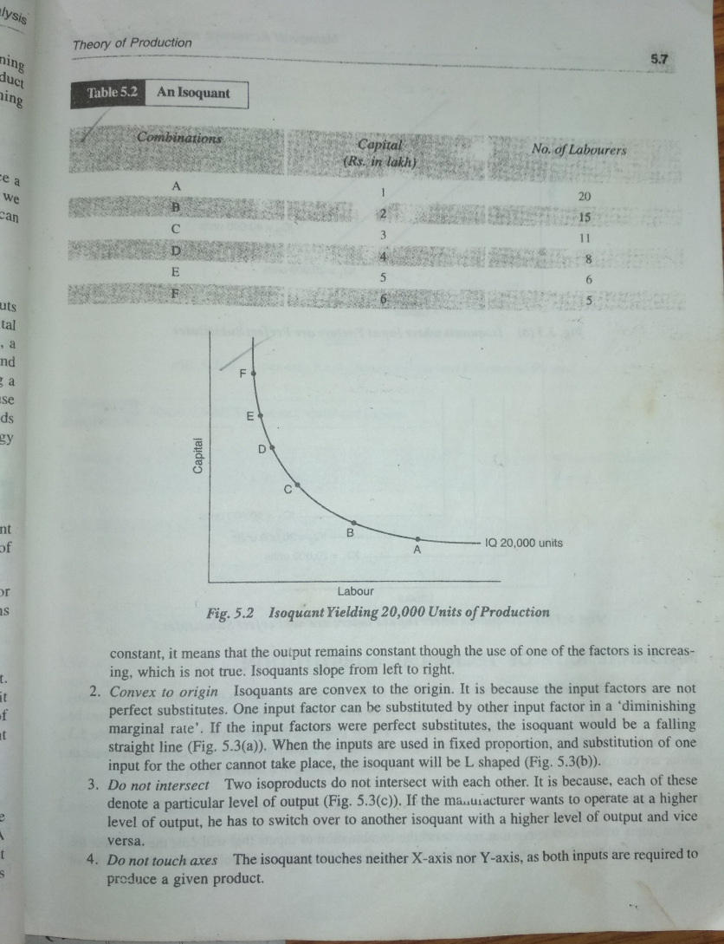

**4.Cost Analysis?**

Costs are very important in business decision-making. Cost of production provides the floor to pricing. It helps managers to take correct decisions, such as what price to quote, whether to place a particular order for inputs or not whether to add a new product to the existing product line and so on. Ordinarily, costs refer to the money expenses incurred by a firm in the production process. But in economics, cost is used in a broader sense. Here, costs include imputed value of the entrepreneur’s own resources and services, as well as the salary of the owner.

**Cost concepts or Types of cost:**

**Fixed Vs Variable costs:**

**Fixed costs** are those costs which are fixed in volume for a certain given output. Fixed cost does not vary with variation in the output between zero and certain level of output. The costs that do not vary for a certain level of output are known as fixed cost. It includes building , Maintenance of land and purchasing machinery.

**Variable costs** are those which vary with the variation in the total output. They are a function of output. Variable costs include cost of raw materials, fuel, repairs, routine maintenance expenditure, direct labor charges associated with the level of output, and the costs of all other inputs that vary with output.

**Opportunity cost:**

The opportunity cost it is also called Alternative cost. Resources are scarce, we cannot produce all the commodities. Opportunity cost of a decision is the sacrifice of alternatives required by that decision. Opportunity cost, therefore, represents the benefits or revenue forgone by pursuing one course of action rather than another.

**Explicit costs Vs Implicit costs:**

**Explicit costs** also known as Out of pocket costs it refer to those which fall under actual or business costs entered in the books of accounts. The payments for wages and salaries, materials, license fee, insurance premium, depreciation charges are the examples of explicit costs. These costs involve cash payments and are recorded in normal accounting practices.

**Implicit costs** also know as imputed cost it refers to those cost are not taken into account while calculating the loss or gains of the business, but they form an important consideration in whether or not a factor would remain in its present occupation.

**Total cost: it** represents the value of the total resource requirement for the production of goods and services. It refers to the total outlays of money expenditure, both explicit and implicit, on the resources used to produce a given level of output. It includes both fixed and variable costs. **Average cost: Average** cost (AC) is of statistical nature, it is not actual cost. It is obtained by dividing the total cost (TC) by the total output (Q), i.e.AC = TC / Q = average cost.

**Marginal cost:**

Marginal cost is the addition to the total cost on account of producing an additional unit of the product. Or, marginal cost is the cost of marginal unit produced.

**Historical and Replacement Costs:**

Historical costs are those costs of an asset acquired in the past. whereas replacement cost refers to the outlay which has to be made for replacing an old asset.

**Short-Run and Long-Run Costs:**

Short-run costs are the costs which vary with the variation in output, the size of the firm remaining the same. In other words, short-run costs are the same as variable costs.

Long-run costs, on the other hand, are the costs which are incurred on the fixed assets like plant, building, machinery, etc. Such costs have long-run implication in the sense that these are not used up in the single batch of production.

**CostDeterminants?**  
The cost of production of goods and services depends on various input factors used by the organization and it differs from firm to firm. The major cost determinants are:  
1.Level of output: The cost of production varies according to the quantum of output. If the size of production is large then the cost of production will also be more.  
2.Price of input factors: A rise in the cost of input factors will increase the total cost of production.  
3.Size of plant: The cost of production will be low in large plants due to mass production with mechanization.

4.Supply chain and logistics: Better the logistics and supply chain, lower the cost of production.  
5.Time period: In the long run cost of production will be stable.  
6.Technology: When the organization follows advanced technology in their process then the cost of production will be low.  
8.Government incentives: If the government provides incentives on input factors then the cost of production will be low.

## 4. Break-even analysis Analysis?

Breakeven analysis also known as cost-volume-profit analysis, , looks to determine the breakeven point for different sales volumes and cost structures, which can be useful for managers making short-term business decisions. BEA analysis makes several assumptions, including that the sales price, fixed and variable costs per unit are constant. Running a BEA analysis involves using several equations for price, cost, and other variables, which it then plots out on an economic graph.

The BEA formula can also calculate the breakeven point. The breakeven point is the number of units that need to be sold or the amount of sales revenue that has to be generated in order to cover the costs required to make the product.

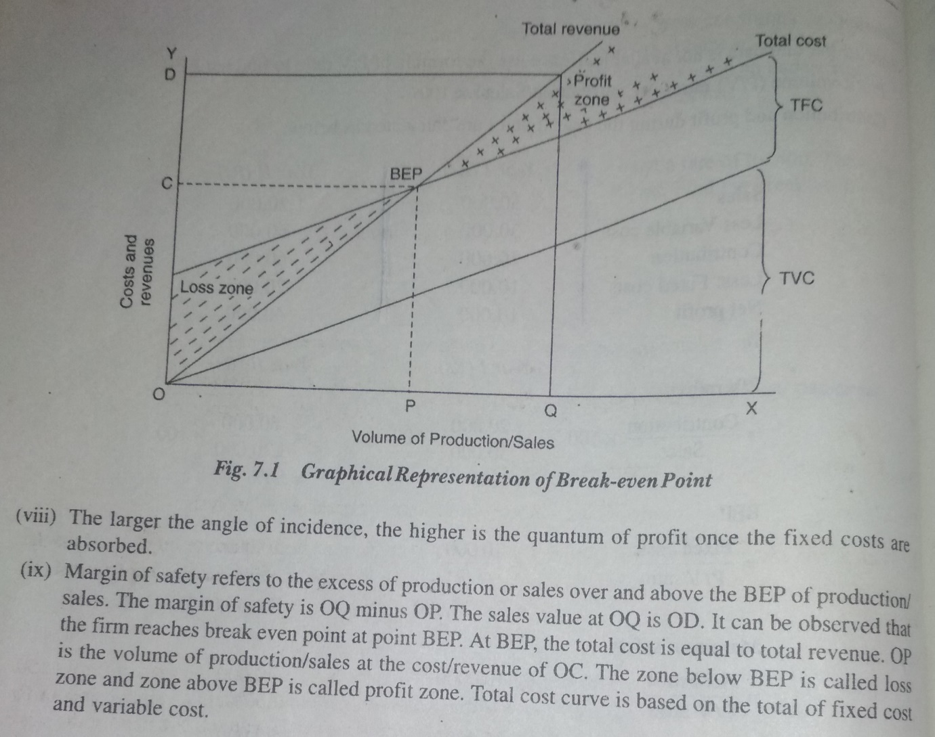

**Assumptions underlying BEA:**

* Cost can perfectly be classified in to fixed and variable cost.
* Selling price does not change with volume change.
* All the goods produced are sold .there is no closing stock.
* There is only one product available for sale.in case of multiple product firms the product mix doesnot change.
* **Key terms used in Break-even Analysis:**
* Fixed cost
* Variable cost
* Total cost
* Total revenue
* Contribution margin: is the difference between selling price per unit and the variable cost per unit.
* Contribution margin ratio: it is the ratio between contribution per unit and the selling price per unit.
* Margin of safety per unit: the excess of actual sales minus break even point . PV Ratio: the ratio between the contribution and sales.

**Managerial Significance and limitations of BEP?**

**Significance of BEP:**

* To ascertain the profit on a particular level of sales volume or a given capacity of production.
* To calculate sales required to earn a particular level of profit.
* To compare the productlines,sales area, methods of sales for individual company.
* To compare the efficiency of the different firms.
* To decide whether to add a particular product to the existing product line or drop one fro it.
* To decide what promotion mix will yield optimum sales.
* To asses the impact of changes in fixed cost ,variable cost or selling price on BEP and profits during a given period of time.

**Limitations of BEP:**

* BEP is based on fixed cost ,variable cost and total revenue. A change in one variable is going to affect on BEP.
* All cost cannot be classified in to fixed cost and variable cost.
* Incase of multiproduct firm a single chart cannot be of any use.

